|  |
| --- |
|  |
| 新概念 3 册 |
| **Lesson9 Flying cats** |

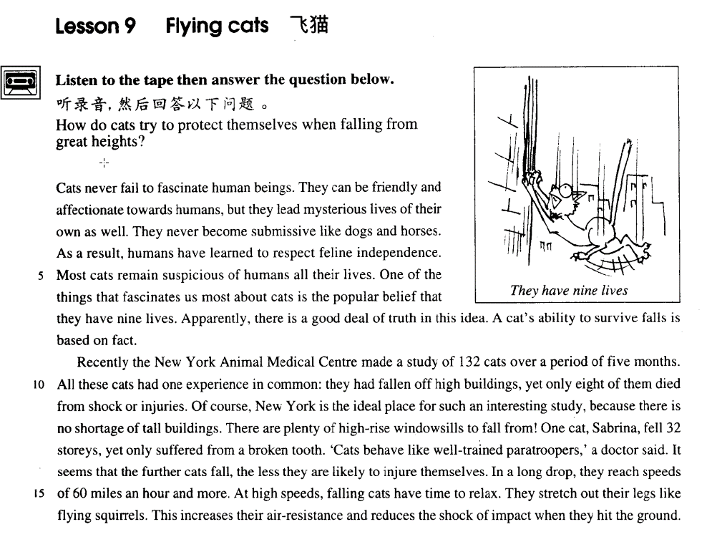

课文

Cats never fail to fascinate human beings.

猫总能引起人们的极大兴趣。

They can be friendly and affectionate towards humans, but they lead mysterious lives of their own as well.

它们可以对人友好，充满柔情。但是，它们又有自己神秘的生活方式。

They never become submissive like dogs and horses.

它们从不像狗和马一样变得那么顺从。

As a result, humans have learned to respect feline independence.

结果是人们已经学会尊重猫的独立性。

Most cats remain suspicious of humans all their lives.

在它们的一生中，大多数猫都对人存有戒心。

One of the things that fascinates us most about cats is the popular belief that they have nine lives.

最使我们感兴趣的一件事情就是一种通俗的信念--猫有九条命。

Apparently, there is a good deal of truth in this idea.

显然，这种说法里面包含着许多真实性。

A cat's ability to survive falls is based on fact.

猫在跌落时能够大难不死是有事实作为依据的。

Recently the New York Animal Medical Centre made a study of 132 cats over a period of five months.

最近，纽约动物医疗中心对132只猫进行了为期5个月的综合研究。

All these cats had one experience in common: they had fallen off high buildings, yet only eight of them died from shock or injuries.

所有这些猫有一个共同的经历：它们都曾从高层建筑上摔下来过，但只有其中的8只猫死于震荡或跌伤。

Of course, New York is the ideal place for such an interesting study, because there is no shortage of tall buildings.

当然，纽约是进行这种有趣的试验的一个理想的地方，因为那里根本不缺乏高楼大厦。

There are plenty of high-rise windowsills to fall from!

有的是高层的窗槛从上往下坠落。

One cat, Sabrina, fell 32 storeys, yet only suffered from a broken tooth.

有一只叫萨伯瑞的猫从32层楼上掉下来，但只摔断一颗牙。

Cats behave like well-trained paratroopers, a doctor said.

“猫就像训练有素的跳伞队员，” 一位医生说。

It seems that the further cats fall, the less they are likely to injure themselves.

看起来，猫跌落的距离越长，它们就越不会伤害自己。

In a long drop, they reach speeds of 60 miles an hour and more.

在一个长长的跌落过程中，它们可以达到每小时60里甚至更快的速度。

At high speeds, falling cats have time to relax.

在高速下落中，猫有时间放松自己。

They stretch out their legs like flying squirrels.

它们伸展四肢，就像飞行中的松鼠一样。

This increases their air-resistance and reduces the shock of impact when they hit the ground.

这样就加大了空气阻力，并减少了它们着地时冲击力带来的震动。

词汇讲解

* **fascinate ['fæsɪneɪt]** v. 迷住，吸引住 （强烈的）
* I am **fascinated** by the story.

**fascinating** ***adj.*** 迷人的；吸引人的；使人神魂颠倒的

* So the story is **fascinating**.

**be / find … endlessly fascinating**

* This city is endlessly fascinating.
* I find the natural world endlessly fascinating.

**fascination *n.*** 魅力；魔力；入迷

**have a … fascination for …**

* The story has a great fascination for me.
* Mars has an extraordinary fascination for would-be voyagers.
* For him, caves have the same peculiar fascination which high mountains have for the climber.

**attract *vt.*** 吸引；引起 ***vi.*** 吸引；有吸引力

* Beijing attracts many investors.

**charm** ***n.*** 魅力，吸引力；魔力 ***vt.*** 使陶醉；行魔法. ***vi.*** 有魔力；用符咒

* The girl charms all the young boys here.

**seduce** ***vt.*** 引诱；诱惑；诱奸；怂恿

**entice** ***vt.*** 诱使；怂恿

* The boss is trying to seduce his secretary.
* I guess I set up the video camera to try and entice Joey.

But sadly I could not be enticed.

* **affectionate** [ə'fekʃənət] adj. 充满深情的，柔情的
* She looked at him in an affectionate way.

**affection** ***n.*** 喜爱，感情；影响；感染

parental affection

maternal affection

paternal affection

* **mysterious** [mɪ'stɪəriəs] adj. 神秘的，难以理解的
* the mysterious pyramids

**mystery *n.*** 秘密，谜；神秘，神秘的事物

**be a mystery to sb.** 对某人来说是个谜

* It's a complete mystery to me why she married him at all!
* **托福听力：**

1. She's not sure how she was able to finish so early.
2. She wasn't able to manage the project well.
3. She's not sure how to solve the mystery.
4. She still hasn't heard what was shocking.

M: I was shocked when I heard you'd finished your research project a whole month early.

W: How I managed to do it is still a mystery to me.

Q: What does the woman mean?

Answer: (A) She's not sure how she was able to finish so early.

* **submissive** [səb'mɪsɪv] adj. 服从的，顺从的
* He was looking for a quiet submissive wife who would obey his every word.

**submit to ...** 服从于….

* First, you must give Helen back to my brother. Second, Troy must **submit to** my command to fight for me whenever I call.

表示“服从于….”

**yield to ...** 屈从

**bow to ...** 鞠躬

**succumb to ...** 屈服

* The government refused to yield / bow / succumb to the terrorists.

**be subject to sth.** 服从于

All employees are subject to the regulations of the company.

* So let us begin anew—remembering on both sides that civility is not a sign of weakness, and sincerity is always subject to proof. Let us never negotiate out of fear, but let us never fear to negotiate.

— John F. Kennedy

* **feline** ['fi:laɪn] adj. 猫的
* She walks with feline grace.

“…ine”结尾的形容词

**canine *adj.*** 犬的；犬齿的；犬科的；似犬的

canine teeth 犬牙

aquiline ***adj.*** 鹰的；似鹰的，像鹰的；钩状的

an aquiline nose 阴沟鼻

porcine ***adj.*** 猪的，像猪的

equine ***adj.*** 马的；象马的

bovine ***adj.*** 牛的；似牛的；迟钝的

bovine spongiform encephalopathy (BSE) mad cow disease 疯牛病

feminine ***adj.*** 女性的；妇女（似）的；阴性的；娇柔的

masculine ***adj.*** 男性的；阳性的；男子气概的

* **independence** [ɪndɪ'pendəns] n. 独立，自主

**Independence Day** 美国独立日

**independence** **from…** 从…获得独立

* India gained **independence** **from** Britain in 1947.

**be independent of ...** 独立的，不依赖的

* His wages enabled him to **become economically independent of** his family.

**be dependent on ... 依赖于**

* They hate **being dependent on** their parents.
* So great is our passion for doing things for ourselves, that we are **becoming increasingly less dependent on** specialized labour.
* **impact** ['ɪmpækt] n. 冲击力，撞击；影响

**on impact** 在撞击时

* The glass smashed **on impact**.

**impact *on / upon* …** 对某人（大）的影响

* His speech had a great **impact *on***me.

**influence / effect *on / upon* …** 对于…的影响

课文讲解

**Flying cats**

* His head was hit by a **falling** stone heavily.
* He received a heavy hit on his head from a falling stone.

* When I came, he was just about to leave.
* My arrival coincided with his departure.

# Cats never fail to fascinate human beings.

**never fail to do sth.** 总是能做某事（褒义）

* My grandson **never fails to** phone me on my birthday.

**语法：**双重否定

* …, because there is no shortage of tall buildings.
* Nor is the city without its moments of beauty.
* It is not uncommon to hear that a shipping company has made a claim for the cost of salvaging a sunken ship.
* She did not fail to keep her word.
* Nobody is without his faults.
* Nothing is impossible to a willing mind.
* No one has nothing to contribute to society.
* I will never read books without falling asleep.
* Cats are endlessly fascinating.
* we find cats endlessly fascinating.

# They can be friendly and affectionate towards humans, but they lead mysterious lives of their own as well.

**be friendly to / towards …** 对…很友好

**be affectionate towards …**对…深情的

* Why **is** he suddenly so friendly to / towards you?
* He is very affectionate towards his children.

**live / lead a … life** 过着…样的生活

* sing a song
* He breathed his last breath.
* Liu died a glorious death.

**… of one’s own** 某人自己的

* I want a room of my own.

# They never become submissive like dogs and horses.

“像…一样”

**as**（副词） … **as** （连词，可以引导比较状语从句）…（肯定）

**as / so … as …（否定 / 疑问）**

课文写法替换：

They never become **as / so** submissive **as** dogs and horses *(do)*.

**in the (same) way that …** “像…一样”

* We like them **in the same way that** we like pretty curtain material.
* Love me **in the way that** I love you.
* The city is living proof that the policy works **in the way that** economists claim.

课文写法替换：

They never become submissive **in the (same) way that** dogs and horses do.

# As a result, humans have learned to respect feline independence.

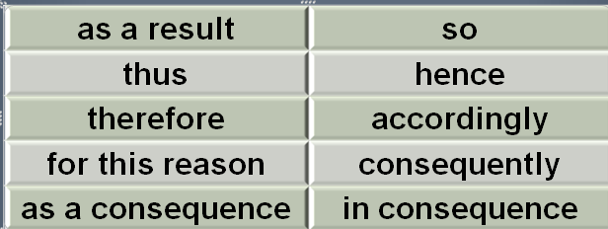

**learn** “学会了”强调结果

* **托福听力：**

1. These things take time to learn.
2. Will you study any more?
3. Why do you keep on making the same mistakes?
4. It will be a good learning experience for you.

When will you ever learn?

Answer: (C) Why do you keep on making the same mistakes?

independence ***n.*** 独立性，自立性；自主

humor ***n.*** 幽默，诙谐；心情

honesty ***n.*** 诚实，正直

**sovereignty *n.*** 主权；主权国家；君主；独立国

**autonomy *n.*** 自治，自治权

* the Inner Mongolia Autonomous Region

# Most cats remain suspicious of humans all their lives.

**be suspicious of / about …** 对…怀疑

* He appeared suspicious. 看起来可疑

**sceptical / skeptical *adj.*** 怀疑的；怀疑论的；习惯怀疑的 （只能是怀疑，不能是可疑）

**be ~ of / about …** 对…怀疑

* I’m highly skeptical of / about his motives.

表“终生”

**all one’s life**

**throughout one’s life**

**区别**

**for life = for the rest of one’s life** 在某人的余生

* The accident crippled him for life.

**lifelong *adj.*** 终身的

a lifelong friendship

a lifelong undertaking

# One of the things that fascinates us most about cats is the popular belief *that they have nine lives*.

**句子分析：**

**1.fascinates 修饰的前面 one**

* Jasper White is one of those rare people who *believes* in ancient myths.
* The Cutty Sark was one of the fastest sailing ships that *has* ever been built.
* **老托福语法题：**

John is the only one of the students in the class (A) that never (B) admit making a mistake even when (C) it is (D) pointed out to him.

John is *the* only *one* of the students in the class (A) that never (B) admit making a mistake even when (C) it is (D) pointed out to him.

改正：John is *the* only *one* of the students in the class that never admit**s** making a mistake even when it is pointed out to him.

**句子分析：**

2.most 在本句中修饰动词“**fascinates**”，most修饰动词最高级不一定加 the

* Those who work (the) most often get paid (the) least.
* **造句**：最令我们感到伤心 (sadden) 的一件事是一种令人沮丧的说法 (a depressing saying)： 每当我们在街上有麻烦或者有危险时没有人**来帮助我们 (come to our assistance)**。

One of the things that saddens us most is a depressing saying that whenever we are in trouble or danger in the street no one will come to our assistance.

# Apparently, there is a good deal of truth in this idea.

**there is a good deal of truth in** … 某个事情很有道理

**there is an element of truth in ….** 有点道理

**there is a truth in** 有道理

* Perhaps there is an element of truth in both this pictures, but few of us have had the opportunity to find out.
* There is probably an element of truth in this argument, but they ignore a more basic fact that the freedom of the press is often abused.
* Albert Einstein once attributed the creativity in a famous scientist to the fact that he never went to school. There is undoubtedly a truth in his observation, but such a truth is not criticism of schools.

# A cat's ability to survive falls is based on fact.

**survive** 本文中表示：经历了某事没有死掉

* In the battle, only four soldiers survived. Only four soldiers survived *the battle*.
* I am especially proud of it, not only because it has survived several severe winters, but because it occasionally produces luscious peaches.

表示“基于…..”“被….支持”

**… is based / founded on fact.**

**… rests on fact.**

**… is supported by fact.**

# Recently the New York Animal Medical Centre made a study of 132 cats over a period of five months.

表示“做…研究”

**make a study of … = study …**

* make a study of human nature
* make a study of human nature carefully
* …, advertisers have made a close（仔细的） study of human nature.

# All these cats had one experience in common: they had fallen off high buildings, *yet* only eight of them died from shock or injuries.

表示“有共同的…”

**have sth. in common**

* … because people’s descriptions of the puma had a lot in common.
* These two species have certain features in common.

share sth. 可表示“有共同的”

* We share an interest in history.
* These two species share certain features.
* All these cats **shared** one experience: …

表示“从…掉下来”

**fall off sth.**

**fall from sth.**

**fall sth.**

**die from …** （更强调外因）

die from shock or injuries / a wound / an accident

**die of …** （更强调内因）

die of a disease / hunger / grief

* As there were strange marks on the X-ray plates taken of the mummy, doctors have been trying to find out whether the woman died of a rare disease.
* It is one of the most unpleasant discoveries which we all make that we must decline in this way, that if we escape wars, accidents and disease we shall eventually 'die of old age', and that this happens at a rate which differs little from person to person, so that there are heavy odds in favour of our dying between the ages of sixty-five and eighty.

# Of course, New York is the ideal（理想的） place for such an interesting study, because there is no shortage of tall buildings.

表示“缺乏”

food / staff **shortage**

**be short of …**

* We’re short of money.
* The refugees are short of food.

**there is a shortage of …**

* There is a shortage of food in the refugee camps.
* There is a shortage（中心名词，用单数） of *nurses and doctors* in this area. there is no shortage of …
* …, because there is no shortage（中心名词，用单数） of tall buildings. （双重否定）
* …, because there are plenty of *tall buildings*. （双重否定）

# There are plenty of high-rise windowsills to fall from!

# One cat, Sabrina, fell 32 storeys, yet only suffered from a broken tooth.

**suffer (from) …** 表示经历某个痛苦的事

* 造句：一个叫 Mike 的出租司机出了 (be involved in …) 一次严重的车祸，然而只断了两根肋骨 (rib)。

One taxi driver, Mike, was involved in a serious car accident, yet only suffered from two broken ribs.

# Cats behave like well-trained paratroopers, a doctor said.

# It seems that the further cats fall, the less they are likely to injure themselves.

比较级

**far --> farther**（距离上的） **/ further**（抽象上的） **--> farthest / furthest**

further development / investigation 更深入的调查

**语法**：“越…越…”比较

**1.两个the 分别放在句首，前半句从句，后半句是主句，从前往后翻译**

The harder they worked(前半句从句，类似条件状语从句) the hungrier they became. （后半句是主句）

**2.第一句the加比较级放在句总，第二句the加比较级放在句首，只能先翻译后半句，再翻译前半句**

They became (the) hungrier （前半句是主句）the harder they worked.（后半句是从句）

* A telescope would have to be as far away as the planet Jupiter to look for life in outer space（主句）, because the dust becomes thinner the further we travel towards the outer edges of our own solar system.（从句）

**补充：主句倒装**

The younger the child is （从句）, the more *is* the child’s need of sleep. （主句，倒装）

**补充：be动词省略**

The younger the child（主句）, the more the child’s need of sleep. （从句）

* The further off this solid obstruction, the longer time will elapse for the return of the echo.
* The further off this solid obstruction *is*, the longer time will elapse for the return of the echo. （be动词省略）

# In a long drop, they reach speeds of 60 miles an hour and more.

# At high speeds, falling cats have time to relax.

**1.speed 做不可数名词时，与 at, with 搭配均可。**

* **e.g.** at / with great speed

**speed 做可数名词时，只能与 at 搭配。**

* **e.g.** at a speed of 60 mph
* The raid was all over in three minutes, for the men scrambled back into the car and it moved off at a fantastic speed.
* Though the new rudder was fitted at tremendous speed, it was impossible for the Cutty Sark to win.
* **老托福语法题：**

― I think John will win the race.

― Yes, he started off a fantastic speed.

(A) with (B) at (C) through (D) by

# They stretch out their legs like flying squirrels.

stretch out

* …, you can enjoy the extraordinary sight of unbroken cloud plains that **stretch out** for miles before you, …
* You can stretch your legs on the spacious decks, ……

stretch one’s legs 伸展腿

squirrel flying squirrel 鼯鼠/飞鼠

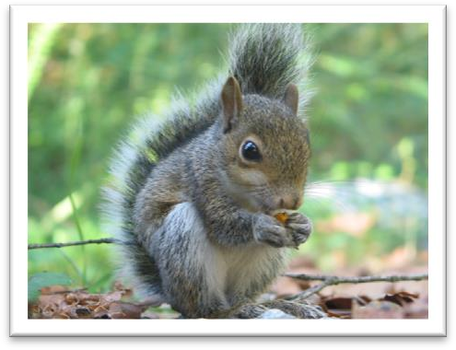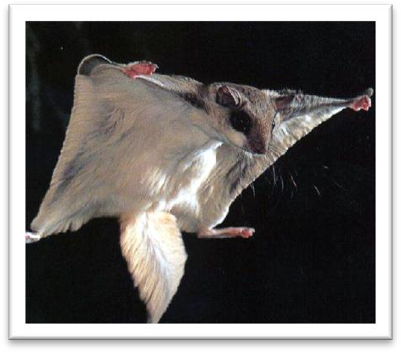

# This increases their air-resistance and reduces the shock of impact when they hit the ground.

# 本文篇章分析

“现象—解释”型说明类文章。题目新奇，引其读者的兴趣。

第一段：引文（猫很迷人，略做陈述）→引出主题（最迷人之处在于有九条命→跌落时不死）

第二段：介绍一项研究并举例→借用医生的话展开解释原理（语言生动风趣）→末尾点题（flying squirrels→flying cats）